Loweswater Villlage Hall: Registered Charity No.: 526856
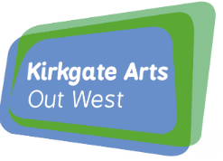Loweswater Village Hall 
Saturday 21st February
7:30 start, doors at 6:45pm
Tickets: Adult £12, U18 £6, Family £25
loweswaterevents@gmail.com tel: 07766 888102.
Light refreshments at interval and licensed bar.

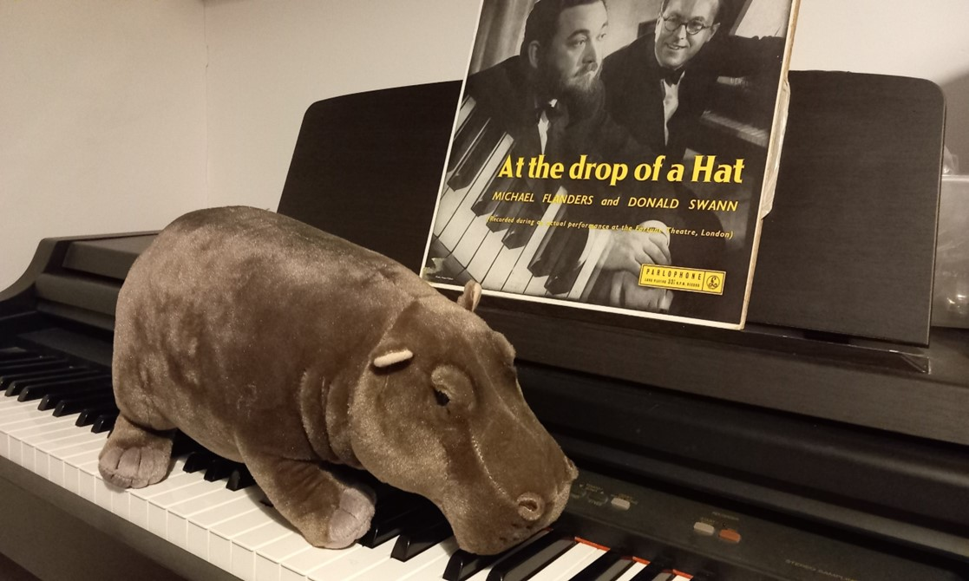
Yes, the Hippo will be there, as well as the Gnu, the Spider and the Whale, slow trains, transports of delight, cannibals, songs of protest and ballads of unrequited love.
Bob Pritchard and Mike Ames present

AT THE DROP OF ^ HIPPOPOTAMUS
celebrating the comic genius of
FLANDERS
& SWANN

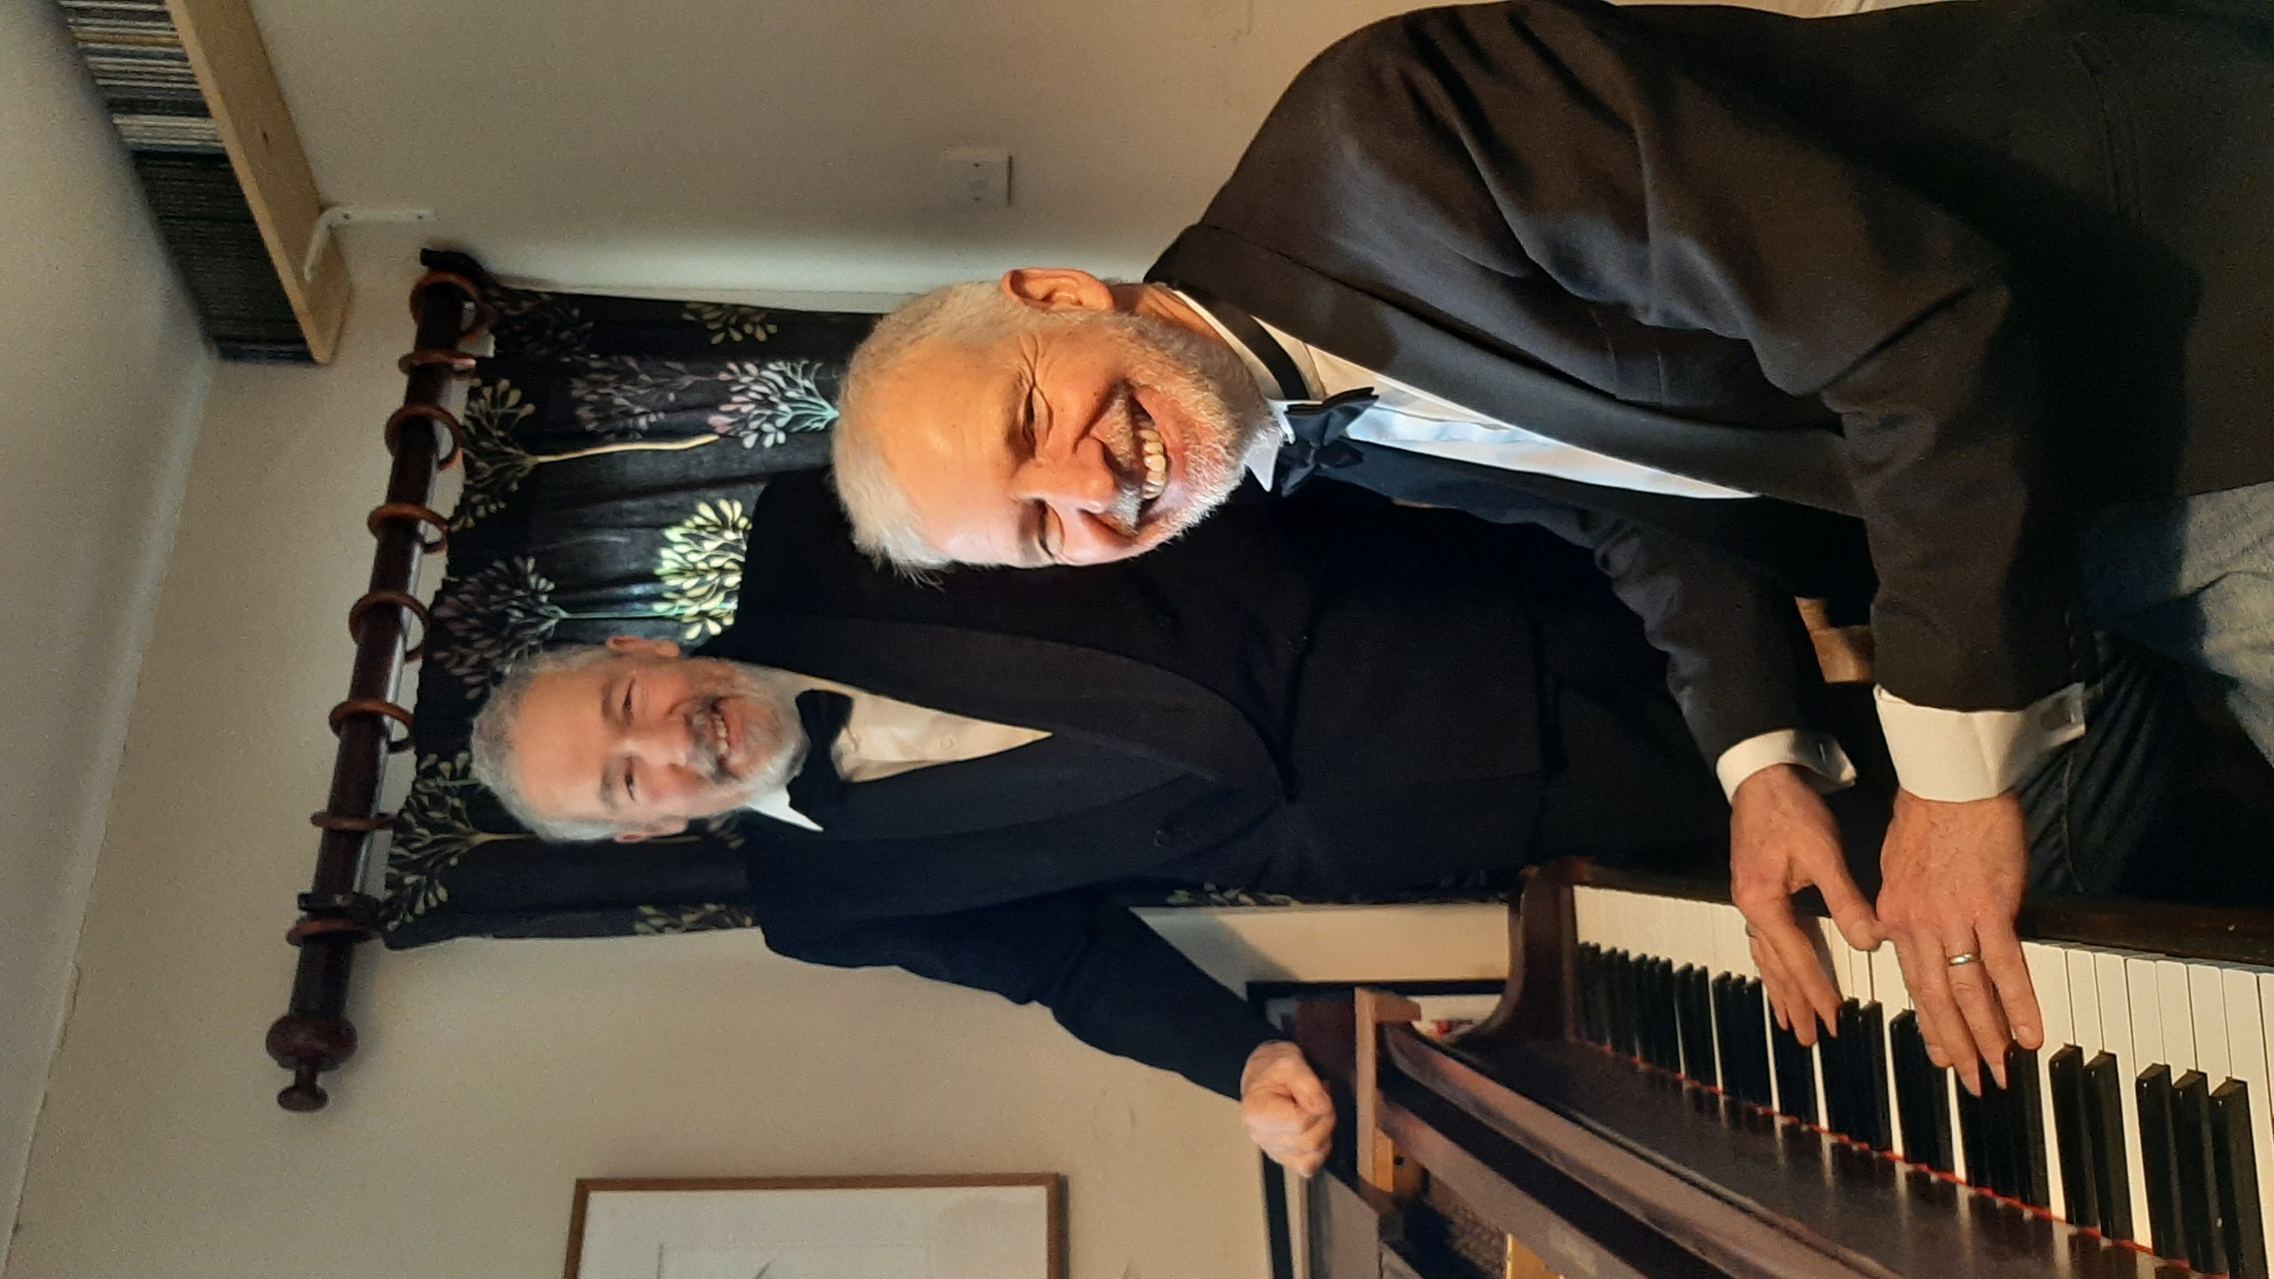
ANOTHER

